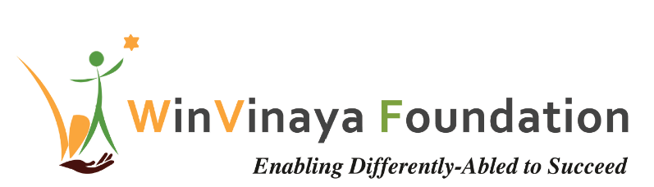

____________________________________________________

Employability Training Program

For Persons with Disability in Bangalore, Karnataka &

Chennai, Tamil Nadu

Proposal by

WinVinaya Foundation

To

SBI Foundation

Date of Proposal: 20th Jan 2020

Project Contact: Sivasankar Jayagopal

Founder Chairman

WinVinaya Foundation

25/3 Brindavan 3rd Cross, Saraswathipuram

IIM Post

Bangalore 560076

Ph.: +91-96764-33359

Email: [Shiva.Jayagopal@WinVinayaFoundation.org](mailto:Shiva.Jayagopal@WinVinayaFoundation.org)

Table of Contents

1 Project Summary 3

1.1 Background 3

2 Introduction about WinVinaya Foundation 3

3 WinVinaya’s Solution Approach 3

3.1 Training at WinVinaya Centers (Bangalore, Chennai) 3

3.2 Boot Camp & Mentoring the trainers – by WinVinaya 4

3.3 WinVinaya’s ePlatforms for Effective Training 5

4 WinVinaya Foundation’s Approach to meet the Training Requirements 5

5 WinVinaya’s Differentiating Factors 7

5.1 4 Step Guided Learning 7

5.2 Sign Language – eSL Platform 8

5.3 Interactive Realtime Dashboards 8

6 Implementation Plan 8

7 Volunteer Engagement 8

7.1 Domain Skill Training/ Soft Skills Training 8

7.2 Mock Interviews 8

7.3 Improve WinVinaya Operations 9

7.4 Connect with employers 9

8 Project Budget Information 10

9 Payment Terms 11

10 Dependencies 11

11 Thanks for the opportunity 11

12 Appendix – 1 – Details of the Project Budget 12

13 Appendix – 2 – Sample Dashboard of WinVinaya Foundation (2018-19) 15

14 Appendix – 3 – Few Success Stories of WinVinaya’s candidates 16

15 Appendix – 4 – Team Building Games at WinVinaya Foundation 17

# Project Summary

## Background

SBI Foundation intends to sponsor employment training program, focused on IT Job Roles in BFSI domain (Banking, Financial Services and Insurance) for 100 persons with disability (PWD) per year for 3 years in each of the 5 locations (Total 1,500 beneficiaries in 3 Years across all locations), which will enable them to join the industry workforce.

In addition to training the candidates, SBI Foundation is looking for WinVinaya Foundation (WinVinaya) to be the SME (Subject Matter Expert) to train the trainers for all the partners selected for this project.

SBI Foundation would like to use the Project Management Dashboard of WinVinaya across all the partners.

# Introduction about WinVinaya Foundation

WinVinaya Foundation, a Charitable Trust was registered in Feb 2016 by Shiva Jayagopal who is an IT Veteran with 28+ years in IT and Seethalakshmi (Akila) who has 15+ years of experience working with Persons with Disabilities. Our primary aim is to empower Persons with Disabilities, economically disadvantaged and women to earn a decent income and lead a life with dignity by providing life skills and resources. We operate a center in Bangalore and a center in Tirupur.

Based on our industry research, we are extending our courses to Ex-Service Persons and Transgender People so that they can earn a better income and lead a life with dignity.

# WinVinaya’s Solution Approach

WinVinaya Foundation would like to provide Training and Placement Assistance services in 2 out of 5 locations. For this, WinVinaya Foundation would enhance the current center in Bangalore and create a new center in Chennai.

WinVinaya Foundation will do it best to adhere to the guideline of training with a mix of 40% Visually Impaired candidates, 40% Hearing Impaired candidates, 15% Locomotor Disabled candidates, 5% Intellectually Disabled candidates.

WinVinaya Foundation will provide Boot Camp to train the trainers of SBI Foundation Partners. To make the training very effective, WinVinaya will provide once a week remote mentoring to all the partners which will be conducted through Skype. WinVinaya will provide once a quarter onsite mentoring to all the partners which will be done at each of the center.

WinVinaya Foundation will enhance the current project management dashboard to cover all the centers. In addition to this, WinVinaya will open up WinVinaya’s eAssessment portal to all the partners which will help in standardizing the assessment across centers for BFSI, Aptitude skills.

## Training at WinVinaya Centers

### Project Goals for Training

* To train 100 Persons with Disabilities per year (Visually Impaired, Hearing & Speech Impaired, Locomotor Disabled, Intellectual Disabled) in Bangalore, Chennai across 3 years (total: 600 beneficiaries) for IT Job Roles in Banking, Financial Services & Insurance sector – which includes software development, software support, core banking operations, operational/ support roles etc.
* Provide interview opportunities for 80% of trained candidates
* Place 50% of the trained candidates in companies and provide post placement support for a minimum of 3 months

### Focus of Digital Skills Training

* Training in BFSI domain, IT
* Training in Soft Skills
* Basic English Communication
* Basic Aptitude
* Mentoring by experts
* Augmented with Digital Learning Platforms
* Will help the candidates learn very effectively and will help them get a job and progress in life.

### Location of WinVinaya Training

* Training for the Persons with Disabilities will be conducted in the existing center in Bangalore and in the new center in Chennai.
* Persons with Disabilities will have to make their own arrangements for travel, food, accommodation.

## Boot Camp & Mentoring the trainers – by WinVinaya

### Project Goals for Boot Camp and Mentoring the trainers

* WinVinaya will conduct the Boot Camp for 1 Week (5 days) at the beginning of the training
* WinVinaya will provide remote mentoring through Skype once a week to each of the centers
* WinVinaya will provide 1 day/ Quarter of Onsite Mentoring to each center

### Focus of Boot Camp and Mentoring the trainers

* WinVinaya will provide orientation on Software Development in Java, SQL to the trainers.
* WinVinaya will work with SBI Foundation on the IT Skills that will be required in the BFSI domain (like KYC, Loan Processing etc.). SBI Foundation will share the topics and any training/ reference material they have. WinVinaya will create relevant training material and provide training to the trainers.
* WinVinaya will provide orientation on the eAssessment Platform on how to use the platform effectively for assessing the candidates at the time of sourcing and during training.
* WinVinaya will provide orientation on how to collect data, report data to WinVinaya so that it can be reported on the Project Management Dashboard. They will be oriented on how to use the reports effectively.

### Location of Boot Camp and Mentoring the trainers

* WinVinaya will provide the boot camp in WinVinaya campus in Bangalore
* Partners will have to make their own arrangements for travel, stay and food

## WinVinaya’s ePlatforms for Effective Training

### eAssessment Platform

* WinVinaya’s eAssessment platform is effective in checking the skill levels of the candidates in Aptitude and has multiple questions on Software coding. This platform will be enhanced to include questions for BFSI domain as well.
* This platform can be used for pre-training assessment to baseline the candidate’s score and for in-training assessments to measure their improvement
* It is currently hosted on Amazon Cloud.

### Dashboard Platform

* WinVinaya’s Dashboard platform showcases the annual goal vs actual in terms of training, placement across batches. This platform will be customized to show information across all the partners. This is currently published using WinVinaya’s Power BI license.

# WinVinaya Foundation’s Approach to meet the Training Requirements

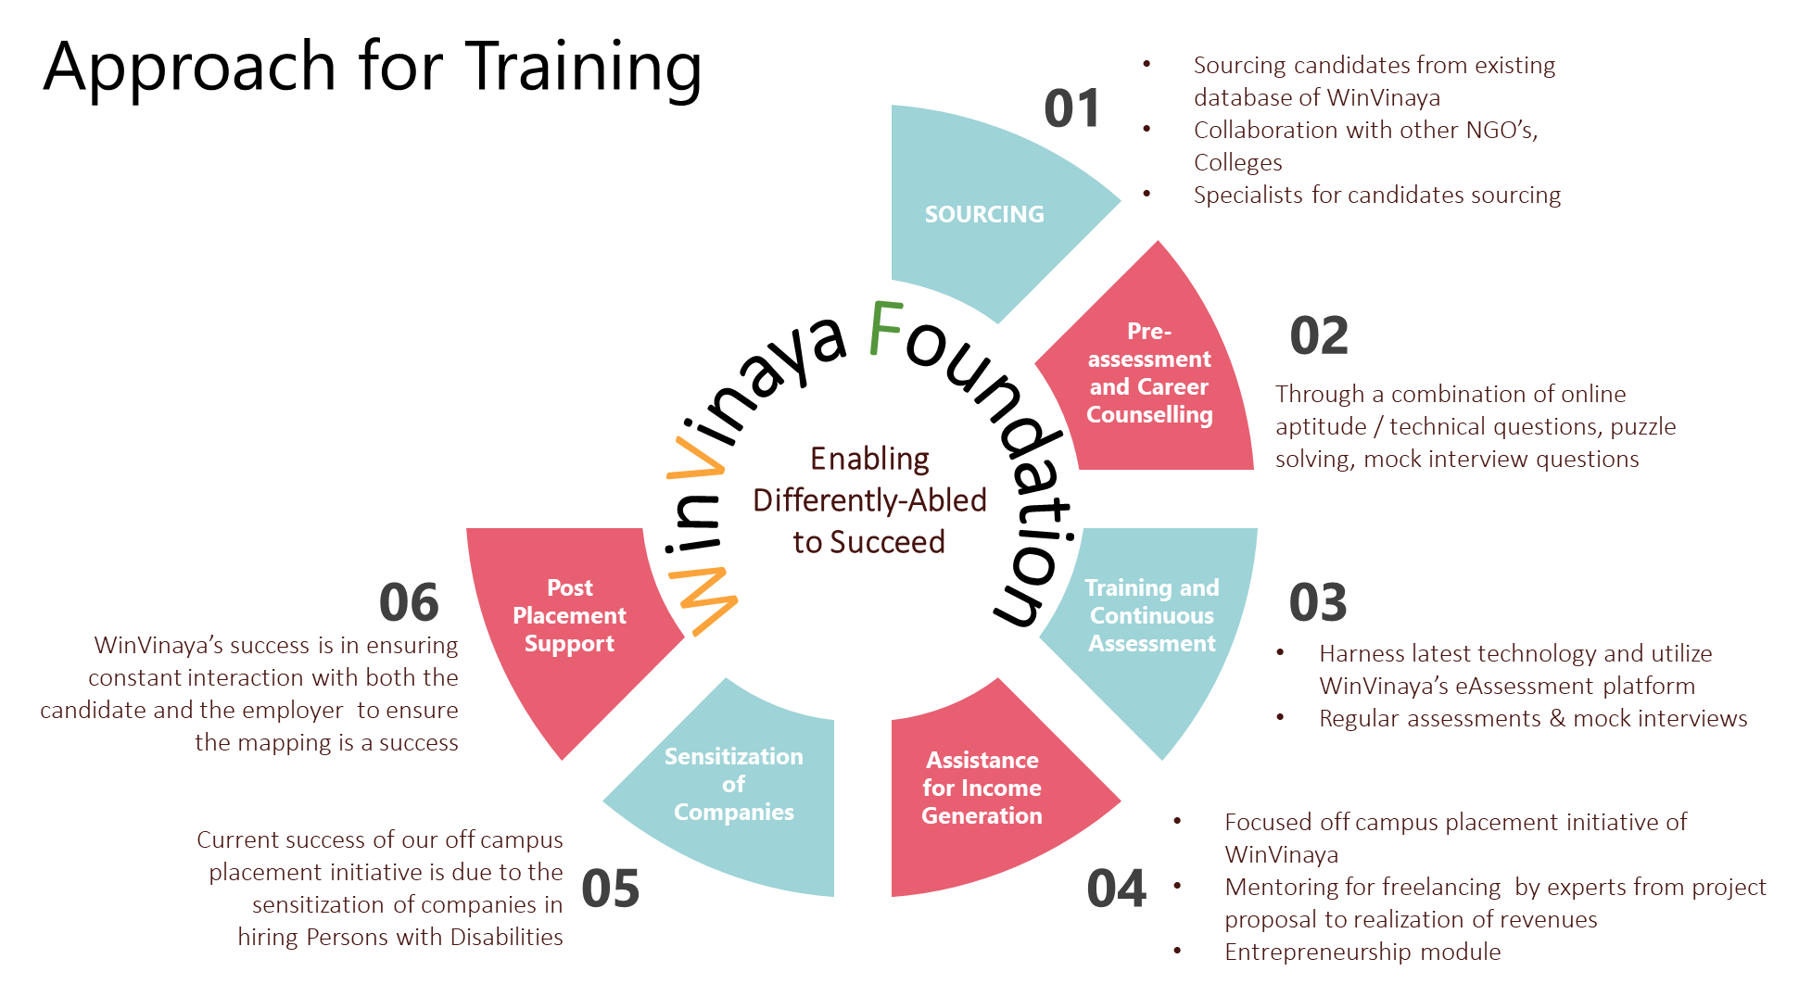

**Sourcing of Candidates for training**

* WinVinaya has a database of candidates who can be trained
* WinVinaya collaborates with colleges, NGOs, Specialists, Social Media, Alumni to source the candidates
* The candidates will be a combination of freshers looking for a job or experienced persons who are looking for better career growth

**Screening & Career Counselling**

* WinVinaya will do a pre-assessment of the candidates through a combination of online aptitude/ technical questions, puzzle solving, mock interview questions to assess their knowledge levels, interests, readiness for jobs and provide career guidance.
* Pre-assessment results help us to choose the appropriate training methodology, duration and make it more effective as per the skills of the candidates.

**Training & Skilling**

* WinVinaya has a track record of training 250+ candidates successfully across various streams – IT/ ITES, Soft skills, HR, Finance, Tally.
* WinVinaya will be using class room training, distant learning using digital learning platforms or a combination of both to provide the training.

**Training Assessments**

* Harness latest technologies - We built WinVinaya’s e-Competency Assessment platform to help the candidates prepare better through multiple practice tests.
* Through WinVinaya’s e-Competency Assessment platform, we regularly check the skill levels of the candidates which will help us make appropriate course correction in the training.
* We conduct 2 Mock interviews - One in the middle of the training and another at the end of the training. This helps in assessing the domain skills and soft skills of the candidates in an interview setting, which greatly helps them in clearing real-time interviews.

**Placement / Recruitment**

* Out of 250+ trained candidates in the last few years, WinVinaya has a track record of placing more than 70% of the candidates.
* WinVinaya’s focused company specific placement drives help in effectively mapping candidates to the recruitment needs of the organizations and facilitate the minimum hit rate of 50% placement

**Sensitization of Companies**

WinVinaya conducts Sensitization Workshop through which we sensitize leaders, managers, team members, Support Teams on the best practices in integrating PWD’s in the workplace. This has helped companies succeed not only in recruiting the candidates but also be successful in embracing them.

**Post Placement Support**

* WinVinaya believes that our part does not end just with placing the candidates. Through our experience we have realized that both Companies and the Candidates need some support, mentoring to ensure that the inclusive journey is successful.
* We provide post placement support to the company and the candidates for minimum 3 months.

# WinVinaya’s Differentiating Factors

WinVinaya Foundation was started and built by IT Veterans. We focus a lot on using effective products, tools, methodologies to make our training very effective. With an experience of training around 250 candidates with about 70% placement, WinVinaya’s successful methodology of harnessing technology is ideal to scale. Our differentiating factor is not on what we train, but on How we train.

**Some of the innovative and effective Products and Tools we intend to use for this program are:**

## 4 Step Guided Learning

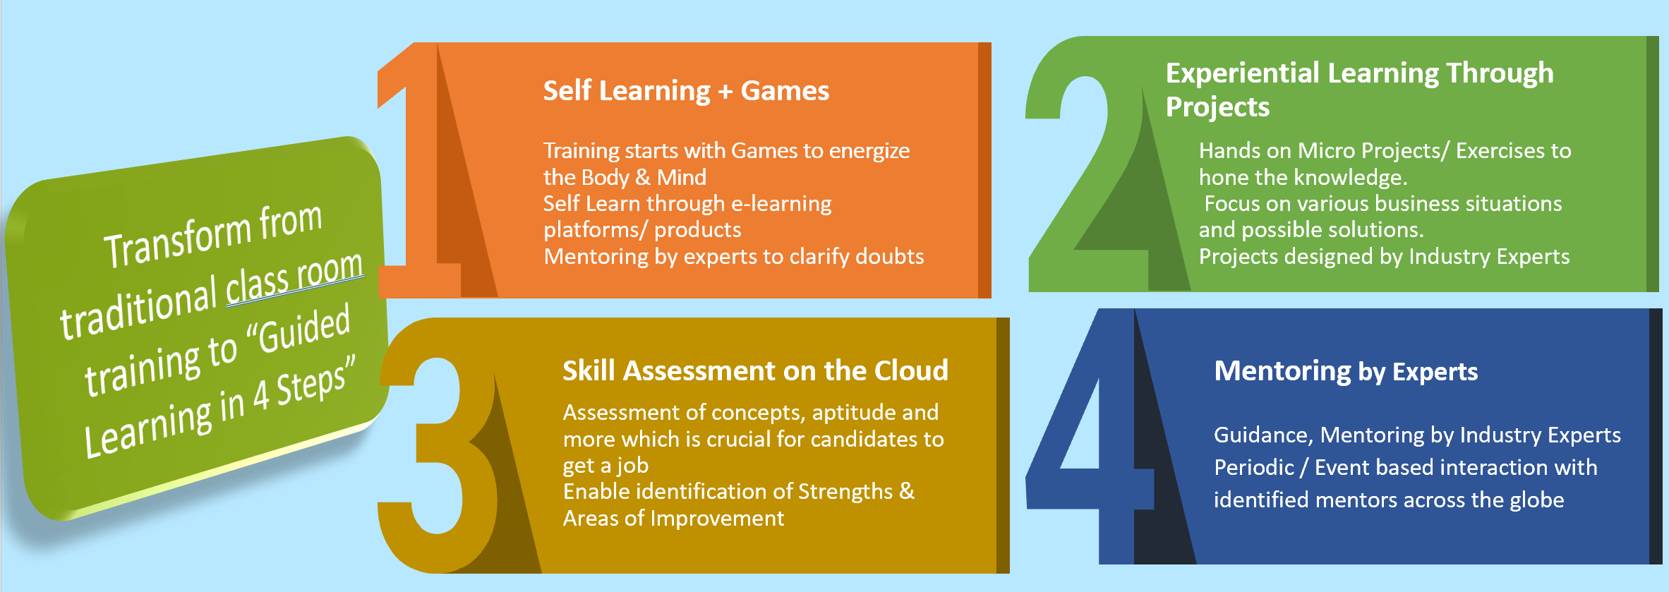

As part of the training, we will implement WinVinaya’s Guided Learning in 4 Steps:

* Self-Learning + Games:
  + Learn English through e-Learning platforms, products – For e.g. Learn English through “Flow of English” product.
  + Learn soft skill training by playing games. Please see a sample video on Team bonding game, here - <https://www.youtube.com/watch?v=XHyp39KYA4U>
* Experiential Learning through Projects
  + With Industry Experts in the foundation, the focus is on creating Projects / Exercises with real time scenarios which will improve the “Application of Knowledge” skills
* Skill Assessment on the Cloud
  + WinVinaya’s eAssessment Platform will be used for evaluating the candidates
  + More than 750 questions on IT, Financial Services Aptitude, English & GK are already loaded on the platform. More BFSI related questions will be added.
  + This platform will be used for Regular Assessments, Pre Training and Post Training Assessments of candidates to understand the Strengths and Areas of Improvement
  + This platform will also be used for mock online test before the Placement
* Mentoring by experts
  + Expert volunteers provide the requisite guidance to the candidates to succeed
  + The guidance would be periodic, and event driven. Their inputs on what they are doing well and what they need to improve along with tips to improve has made a very big difference for the candidates to succeed.

## Sign Language – eSL Platform

Many Hearing & Speech Impaired candidates communicate through Sign Language. However, the companies that are willing to recruit them don’t have many employees who know Sign Language. WinVinaya has created “WinVinaya eSL”. This is a self-learning course where anyone can learn the foundations of Sign Language through videos structured through a lesson plan. Within a few days, the Basic Sign Language course can be completed.

We strongly believe that platforms like these will enable the community to learn Sign Language which will help make this world become more inclusive.

## Interactive Realtime Dashboards

WinVinaya Foundation believes not just in collating the information and reporting on periodic basis, but also in analyzing the information for further improvements. To this end, we built dashboards for Monitoring Training, Placement of candidates. Please see Appendix 2 for the sample dashboard.

# Implementation Plan

|  |  |
| --- | --- |
| Training Location | WinVinaya’s Existing Center in Bangalore; New Center in Chennai |
| No. of Beneficiaries | 100/ year * 3 Years * 2 Locations = 600 |
| Duration of the Course | 150 Hours to 200 Hours – approximately 6 weeks to 8 weeks per student  Batch Duration may vary slightly from plan depending on the batch needs and the skill of the candidates |
| Overall Project Duration | 36 months |

# Volunteer Engagement

Employees of SBI Foundation are most welcome to volunteer and support our initiatives and enable PWDs to lead a life with dignity. There are multiple ways in which volunteers can make a positive impact-.

## Domain Skill Training/ Soft Skills Training

Volunteers can provide training for one or more days on improving domain skills, communication, increasing confidence, interviewing skills, teamwork and more through classroom mode, fun filled games.

## Mock Interviews

Volunteers can be part of mock interviews which helps the candidates to shed their fear and anxiety in facing interviews. Provide authentic feedback on what the candidates did well and where they should improve.

## Improve WinVinaya Operations

Volunteers can help WinVinaya to improve the entire process (from sourcing candidates to placing the candidates to getting funds from sponsors) or selected few key process areas, to significantly increase the social impact.

## Connect with employers

SBI Foundation can immensely help in the placement of the candidates by connecting WinVinaya to potential employers.

# Project Budget Information

|  |  |  |  |  |  |
| --- | --- | --- | --- | --- | --- |
| **Cost head** | **Description** | **Year-1** | **Year-2** | **Year-3** | **Total** |
| Capex Cost – New Center (Chennai) | Cost includes setting up of Infrastructure – including Computer Lab Setup (25 Laptops), Training Room Setup, Office Setup along with Assistive Devices | ₹36,82,000 | - | - | **₹36,82,000** |
| Opex Cost for Chennai (New Location) | Training cost including Rental, Mobilization, Training, Assessments, Placement | ₹33,20,000 | ₹36,52,000 | ₹ 40,17,200 | **₹1,09,89,200** |
| Capex Cost – Enhancing Existing Center (Bangalore) | Additional 10 Laptops, Projector, Assistive Devices | ₹16,10,000 | - | - | **₹16,10,000** |
| Opex Cost for Bangalore (Existing Center) | Training cost including Rental, Mobilization, Training, Assessments, Placement | ₹30,80,000 | ₹33,88,000 | ₹37,26,800 | **₹1,01,94,800** |
| **Sub Total** | **Training Budget** | **₹1,16,42,000** | **₹70,40,000** | **₹ 77,44,000** | **₹2,64,76,000** |
| Boot Camp | Boot Camp at the beginning for 1 Week | ₹1,00,000 | ₹1,10,000 | ₹1,21,000 | **₹3,31,000** |
| Remote Monitoring of Other Centers from Bangalore | 4 Weeks a month for 12 months for all the remaining 3 Centers | ₹7,20,000 | ₹ 7,92,000 | ₹8,71,200 | **₹23,83,200** |
| Onsite Monitoring of Other Centers | Once a Quarter for 3 Centers | ₹7,20,000 | ₹7,92,000 | ₹8,71,600 | **₹23,83,200** |
| **Sub Total** | **Boot Camp and Mentoring the Trainers Budget** | **₹15,40,000** | **₹16,94,000** | **₹18,63,400** | **₹50,97,400** |
| eAssessment - Add Questions for BFSI | Add questions which are used for assessing candidates across locations | ₹30,000 | ₹33,000 | ₹ 36,300 | **₹99,300** |
| eDashboard - Enhancement | Enhancement to additional project management metrics, centers; Approximate effort 12 Person days | ₹3,00,000 | ₹3,30,000 | ₹3,63,000 | **₹9,93,000** |
| **Sub Total** | **ePlatform - WinVinaya Cost Budget** | **₹3,30,000** | **₹3,63,000** | **₹3,99,300** | **₹10,92,300** |
| eAssessment Platform Cost | AWS License | ₹72,000 | ₹79,200 | ₹ 87,120 | **₹2,38,320** |
| eDashboard Platform Cost | Power BI Licenses - Pro | ₹2,00,000 | ₹2,20,000 | ₹2,42,000 | **₹6,62,000** |
| **Sub Total** | **ePlatform - License Cost** | **₹2,72,000** | **₹2,99,200** | **₹3,29,120** | **₹9,00,320** |
| **Total** | | **₹1,38,34,000** | **₹93,96,200** | **₹1,03,35,820** | **₹3,35,66,020** |

More details of the project budget is given in Appendix-1

# Payment Terms

|  |  |  |
| --- | --- | --- |
| **Cost head** | **Release of Amount** | **Amount** |
| Capex Cost – New Center (Chennai) | 100% of the amount within a week of signing the agreement | ₹36,82,000 |
| Capex Cost – Enhancing Existing Center (Bangalore) | 100% of the amount within a week of signing the agreement | ₹16,10,000 |

|  |  |
| --- | --- |
| **Cost head** | **Release of Amount** |
| Opex Cost | 25% of the budget before the start of the training |
| 30% after completion of training of 50% of the candidates |
| 30% after completion of training of 100% of the candidates |
| 15% after placement of 50 candidates and year end report |

Invoices will be raised for Boot Camp & Mentoring the trainers and ePlatform and we request payment within 30 days of raising the invoice.

# Dependencies

WinVinaya requests SBI Foundation to provide 3 months from the date of agreement to start the engagement.

WinVinaya requests SBI Foundation to have the other 3 centers to align the trainers for the Bootcamp program.

WinVinaya requests SBI Foundation to provide the topics, training reference materials to WinVinaya Foundation 2 weeks before the agreement

# Thanks For The Opportunity

Based on our experience, we are confident that we would be able to execute this project as per the expectations of SBI Foundation in the journey of bringing a positive change in the lives of Persons with Disability. WinVinaya takes this moment to thank the SBI Foundation for providing this opportunity for creating a positive impact on our society.

# Appendix – 1 – Details of the Project Budget

**Capex for New Center (Chennai)**

|  |  |  |
| --- | --- | --- |
| **Cost head** | **Description** | **Total** |
| Computer Lab | Computer Tables, Chairs, 25 Laptops with Windows 10, MS Office, Printer & Scanner, Networks | ₹18,81,000 |
| Accessible Devices | 10 Licenses of JAWS, 2 Accessible Scanner & Reader (Trestle Labs) | ₹8,60,000 |
| Training Room | Projector, Whiteboards | ₹44,000 |
| Office Setup | CCTV, BioMetrics, Inverter, Fans, Name Boards, Wheel Chairs etc. | ₹2,97,000 |
| Advance | Advance for Rental Space | ₹6,00,000 |
| **Total** | | ₹**36,82,000** |

**Capex for Existing Center (Bangalore)**

|  |  |  |
| --- | --- | --- |
| **Cost head** | **Description** | **Total** |
| Computer Lab | Computer Tables, Chairs, 10 Laptops with Windows 10, MS Office | ₹7,06,000 |
| Accessible Devices | 10 Licenses of JAWS, 2 Accessible Scanner & Reader (Trestle Labs) | ₹8,60,000 |
| Training Room | Projector, Whiteboards | ₹44,000 |
| **Total** | | **₹16,10,000** |

**Opex Budget for New Center (Chennai)**

|  |  |  |  |  |
| --- | --- | --- | --- | --- |
| **Cost head** | **Description** | **Units** | **Unit cost** | **Total** |
| Cost of facilities | Rentals for premise | 12 | ₹ 60,000 | ₹ 7,20,000 |
| Mobilization of candidates | Cost of outreach (travel; meetings & mobilization sessions; social media; internet; counselling, advertisement/flyers; pre-assessment, enrolments ) | 100 | ₹ 1,500 | ₹ 1,50,000 |
| Training of candidates | Training cost including cost of accessible study materials, sign language interpreter, accommodation for some candidates, systems and software, Broadband/ Network, Computer Maintenance, Events like Mock Interview, Certificate Distribution, and retraining wherever needed | 100 | ₹ 22,000 | ₹ 22,00,000 |
| Assessments | Online and Offline Assessments | 100 | ₹ 500 | ₹ 50,000 |
| Job placement | Including branding, food and travel  costs for candidates, sign language interpreter costs | 100 | ₹ 2,000 | ₹ 2,00,000 |
| **Total for Year-1** | | | | **₹ 33,20,000** |
| **10% Increase for Year-2** | | | | **₹ 36,52,000** |
| **10% Increase for Year-3** | | | | **₹ 40,17,200** |
| **Total** | | | | **₹ 1,09,89,200** |

**Opex Budget for Existing Center (Bangalore)**

|  |  |  |  |  |
| --- | --- | --- | --- | --- |
| **Cost head** | **Description** | **Units** | **Unit cost** | **Total** |
| Cost of facilities | Rentals for premise | 12 | ₹ 40,000 | ₹ 4,80,000 |
| Mobilization of candidates | Cost of outreach (travel; meetings & mobilization sessions; social media; internet; counselling, advertisement/flyers; pre-assessment, enrolments ) | 100 | ₹ 1,500 | ₹ 1,50,000 |
| Training of candidates | Training cost including cost of accessible study materials, sign language interpreter, accommodation for some candidates, systems and software, Broadband/ Network, Computer Maintenance, Events like Mock Interview, Certificate Distribution, and retraining wherever needed | 100 | ₹ 22,000 | ₹ 22,00,000 |
| Assessments | Online and Offline Assessments | 100 | ₹ 500 | ₹ 50,000 |
| Job placement | Including branding, food and travel  costs for candidates, sign language interpreter costs | 100 | ₹ 2,000 | ₹ 2,00,000 |
| **Total for Year-1** | | | | **₹ 30,80,000** |
| **10% Increase for Year-2** | | | | **₹ 33,88,000** |
| **10% Increase for Year-3** | | | | **₹ 37,26,800** |
| **Total** | | | | **₹ 1,01,94,800** |

**Boot Camp & Mentoring of Trainer Budget**

|  |  |  |  |  |
| --- | --- | --- | --- | --- |
| **Cost head** | **Description** | **Units** | **Unit cost** | **Total** |
| First Time Orientation | Train the Trainers at the beginning of the program for 5 Business Days | 5 | ₹ 20,000 | ₹ 1,00,000 |
| Remote Monitoring of Other Centers from Bangalore | For Remaining 51 weeks of the year for all the 4 Centers | 204 | ₹ 5,000 | ₹ 10,20,000 |
| Onsite Monitoring of Other Centers | Once a Quarter for 4 Centers | 16 | ₹ 60,000 | ₹ 9,60,000 |
| **Total for Year-1** | | | | **₹ 20,80,000** |
| **10% Increase for Year-2** | | | | **₹ 22,88,000** |
| **10% Increase for Year-3** | | | | **₹ 25,16,800** |
| **Total** | | | | **₹ 68,84,800** |

**ePlatform Budget**

**For WinVinaya**

|  |  |  |  |  |
| --- | --- | --- | --- | --- |
| **Cost head** | **Description** | **Units** | **Unit cost** | **Total** |
| eAssessment - Add Questions for BFSI | Add questions which are used for assessing candidates across locations | 1 | ₹ 30,000 | ₹ 30,000 |
| eDashboard - Enhancement | Enhancement to additional project management metrics, centers; Approximate effort 12 Person days | 12 | ₹ 25,000 | ₹ 3,00,000 |
| **Total for Year-1** | | | | **₹ 3,30,000** |
| **10% Increase for Year-2** | | | | **₹ 3,63,000** |
| **10% Increase for Year-3** | | | | **₹ 3,99,300** |
| **Total** | | | | **₹ 10,92,300** |

**For Platform Licenses**

|  |  |  |  |  |
| --- | --- | --- | --- | --- |
| **Cost head** | **Description** | **Units** | **Unit cost** | **Total** |
| eAssessment Platform Cost | AWS for 1 Month | 12 | ₹ 6,000 | ₹72,000 |
| eDashboard Platform Cost | Power BI Pro – 20 Licenses for 1 year | 20 | ₹ 10,000 | ₹ 2,00,000 |
| **Total for Year-1** | | | | **₹ 2,72,000** |
| **10% Increase for Year-2** | | | | **₹ 2,99,200** |
| **10% Increase for Year-3** | | | | **₹ 3,29,120** |
| **Total** | | | | **₹ 9,00,320** |

# Appendix – 2 – Sample Dashboard of WinVinaya Foundation (2018-19)

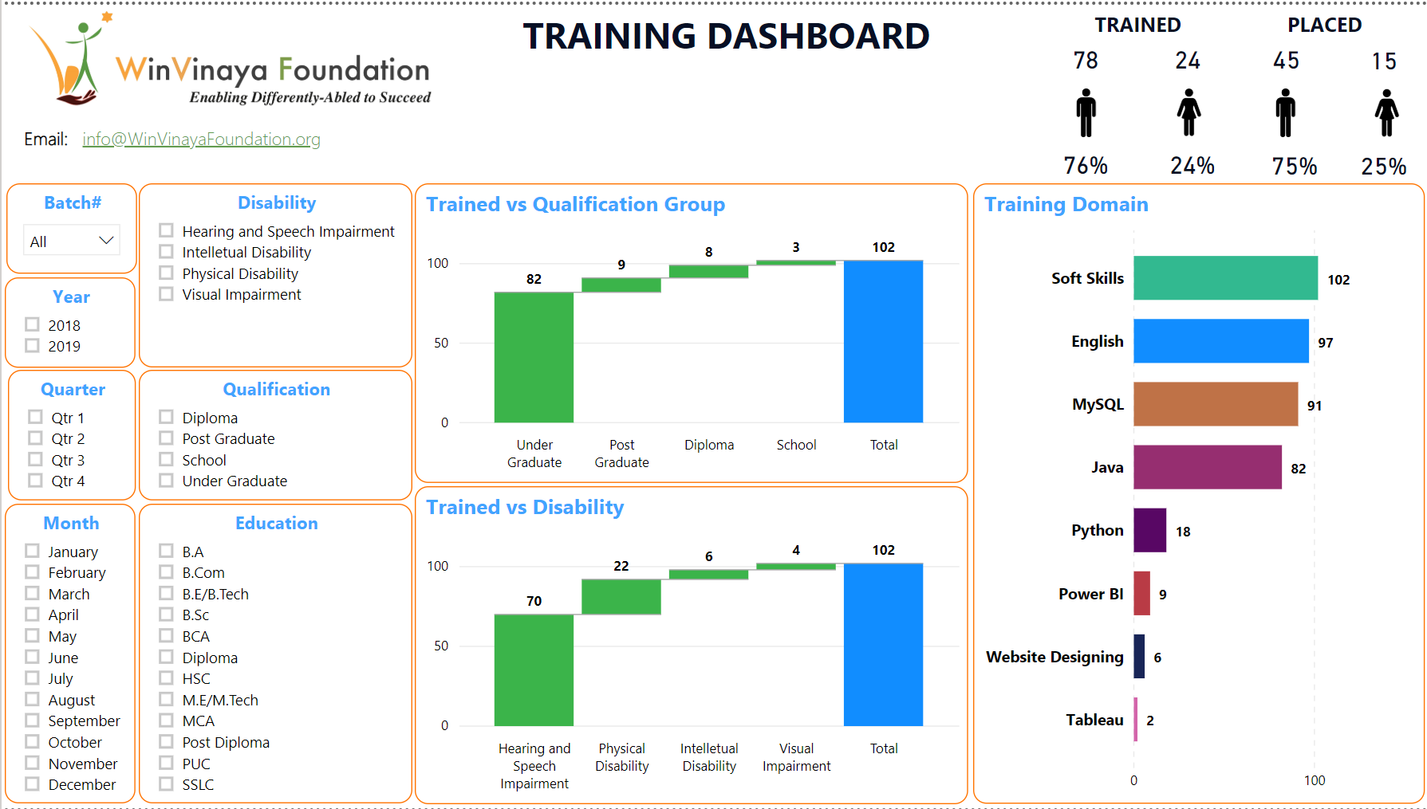

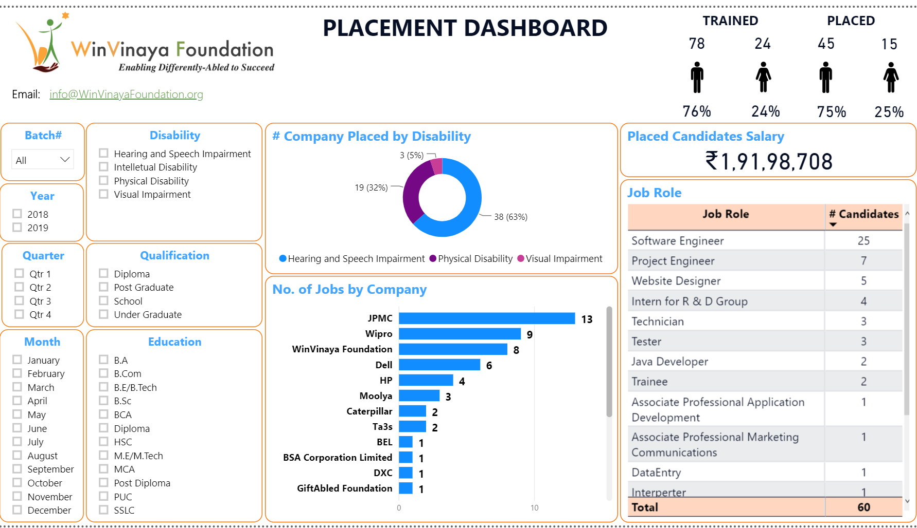

# Appendix – 3 – Few Success Stories of WinVinaya’s candidates

1. **Success Story of Anoop**

Anoop is a Hearing & Speech Impaired person from Kerala. He uses Sign Language to communicate. Even though there are 400+ educational institutions for the deaf in India, almost 95% of them don’t have qualified sign language instructors. In other words, we are NOT educating the deaf in an effective way.

Anoop experienced this the hard way. But then, Anoop is a strong willed, smart, hard working person. Watch this video to see how Anoop transformed his life - [Success Story of Anoop](https://www.youtube.com/watch?v=b-rXnVXsSo4)

1. **Success Story of Lohith**

Lohith is a Person with Low Vision from Karnataka. He wanted to do Engineering, which includes design drawings, practicals, labs… Some raised questions if that is the right course for him. He took it as a challenge and completed Mechanical Engineering.

He then decided to explore the IT sector. He got himself trained in software development and landed a job in a top MNC. When there is a will, there is a way. Watch his story - [Success Story of Lohith](https://www.youtube.com/watch?v=uhxWfwuIVlE&t=148s)

1. **Success Story of Jayashree**

Jayashree is a Person with Locomotor Disability from Karnataka. When she was born, her parents were very worried about the future of their girl child with disability. It was NOT easy to get school admission.

Fast Forward. Jayashree completed MCA. She fine tuned her skills and is now working in a top MNC & is the primary bread winner of her family - A Person with Disability supporting people without disabilities. Watch her story of GRIT – [Success Story of Jayashree](https://www.youtube.com/watch?v=baxYr3XPDPM&t=16s)

# Appendix – 4 – Team Building Games at WinVinaya Foundation

Games are an integral part of learning at WinVinaya Foundation. We harness the power of games to improve self confidence, enhance logical thinking & reasoning, team building skills, leadership building skills.

**Given below are the videos of some of the games played at WinVinaya Foundation.**

**Leadership Building Games -** [**https://www.youtube.com/watch?v=pk7A2fg7Y5A**](https://www.youtube.com/watch?v=pk7A2fg7Y5A) **Team Co-ordination Games -** [**https://www.youtube.com/watch?v=XHyp39KYA4U**](https://www.youtube.com/watch?v=XHyp39KYA4U) **Team Building Games -** [**https://www.youtube.com/watch?v=F_iDYr55HFI**](https://www.youtube.com/watch?v=F_iDYr55HFI)

